**Ideation Phase**

**Define the Problem Statements**

|  |  |
| --- | --- |
| Date | 26 October 2022 |
| Team ID | PNT2022TMID08358 |
| Project Name | Industry-Specific Intelligent Fire Management System |
| Maximum Marks | 2 Marks |

**Customer Problem Statement Template:**

Create a problem statement to understand your customer's point of view. The Customer Problem Statement template helps you focus on what matters to create experiences people will love.

A well-articulated customer problem statement allows you and your team to find the ideal solution for the challenges your customers face. Throughout the process, you’ll also be able to empathize with your customers, which helps you better understand how they perceive your product or service.

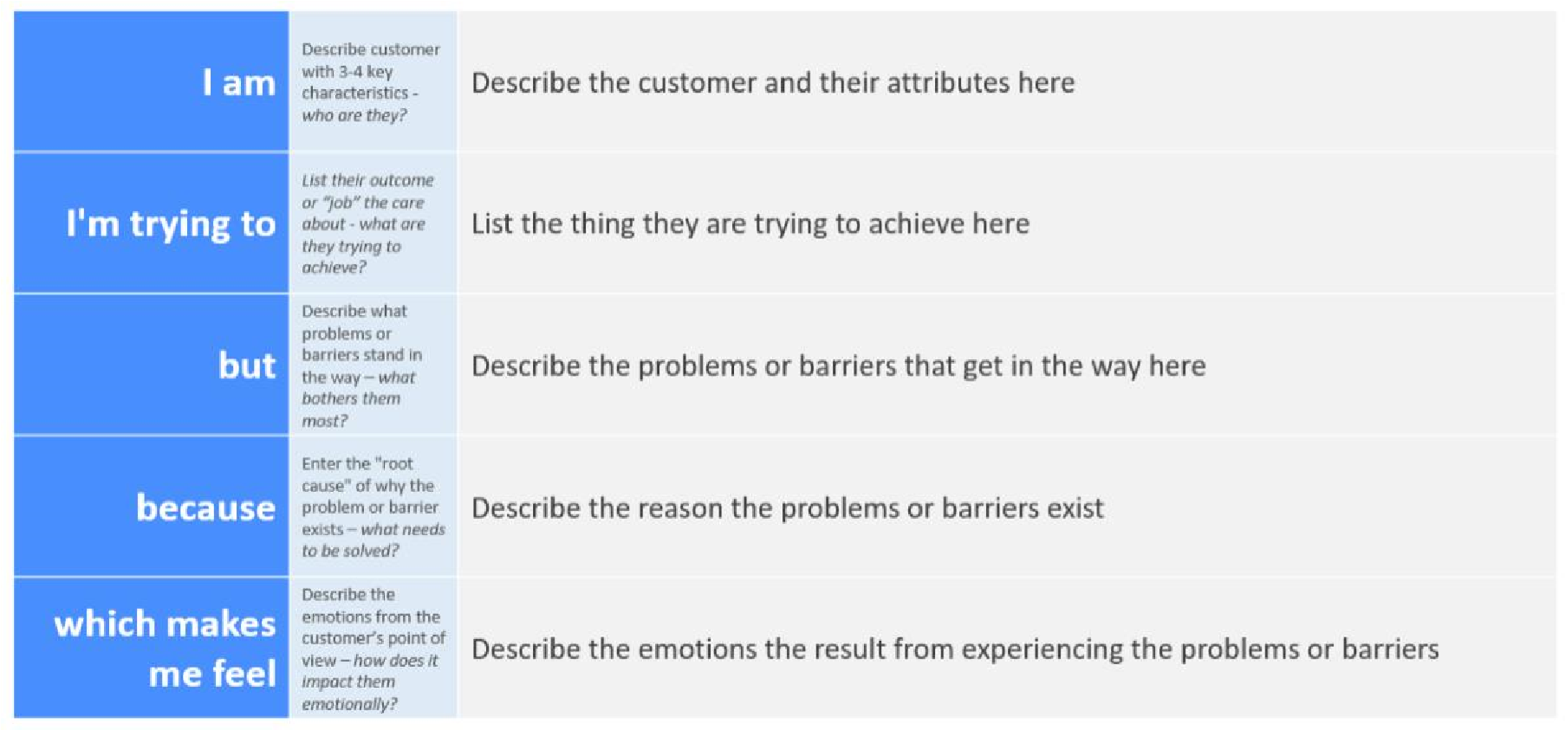

Reference: <https://miro.com/templates/customer-problem-statement/>**Example:**

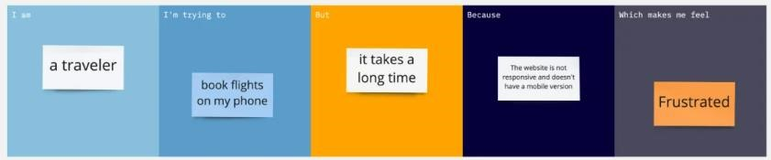

|  |  |  |  |  |  |
| --- | --- | --- | --- | --- | --- |
| **Problem**  **Statement (PS)** | **I am**  **(Customer)** | **I’m trying to** | **But** | **Because** | **Which makes me**  **feel** |
| PS-1 | I am an industry owner | I’m trying to safeguard my employees and properties from fire | But I don’t have a  proper fire  management system that detects fire immediately | Because employees,can’t detect fire immediately, Meanwhile, disasters may happen | As a result, I need a fire management system that will detect the fire immediately, and the alarm and the sprinkler will be turned on simultaneously |
| PS-2 | I am an industry owner | I’m trying to get a fire  management  system that monitors the temperature and gas values in my industry | But I don’t have such a system that makes me aware of the temperature and gas values in my industry | Because I need to know the temperature and gas values in the surroundings to keep me more  aware of the  fire | As a result, I need a fire management system that keeps me more aware |